**Chapter 10: BASICS OF TRANSACTION PROCESSING**

**Transaction**

* Set of instructions and operations.
* It accesses and updates certain data.
* Similar to functions.
* Written in DML or high-level language.

**ACID Properties**

* **Atomicity**
* **Consistency:** No parallel/concurrent executions + maintain of data integrity.
* **Isolation:** Multiple transactions done in series, not parallel.
* **Durability:** Changes are saves even if system fails.

**Atomicity Example**

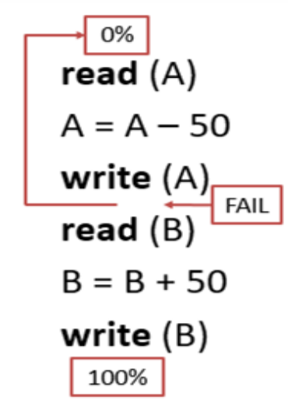

**Consistency Example**

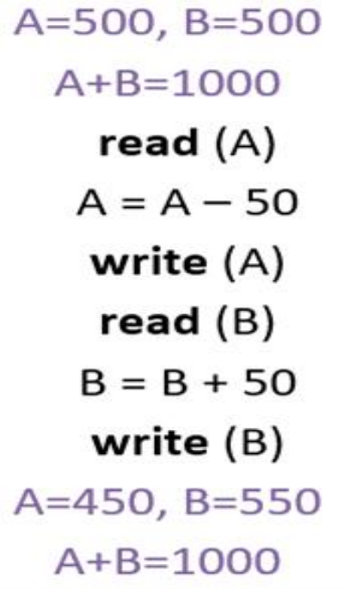

**Isolation Example**

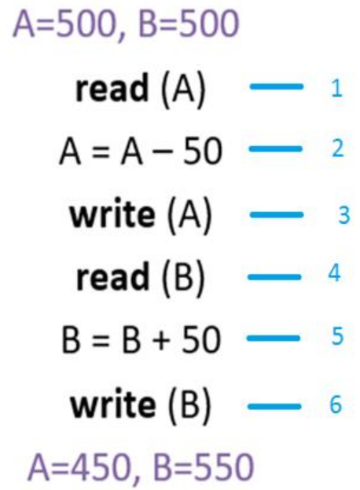

* Can be called as atomicity of each individual statement.

**Durability**

***\*Same example as the isolation example\****

**Transaction State**

* **Aborted**
* **Rolled back**
* **Committed**
* **Compensating transaction:** Undo committed transactions.

**Transaction State Diagram**

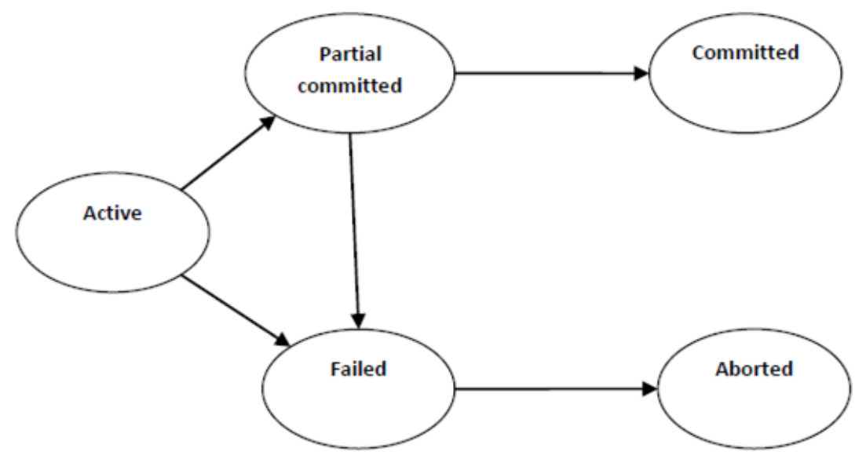

**Transaction State In Brief**

***\*All states shown in diagram above\****

**Transaction Log**

* Keeps record of all past transactions.
* **These records include:**
  + Type of operations done.
  + Data affected by it.
  + Before and after values of data.
  + Commit points of transaction.
* **Advantage:** Ability to search for corrupt point in data.
* **Disadvantage:** Load and storage of too much information.